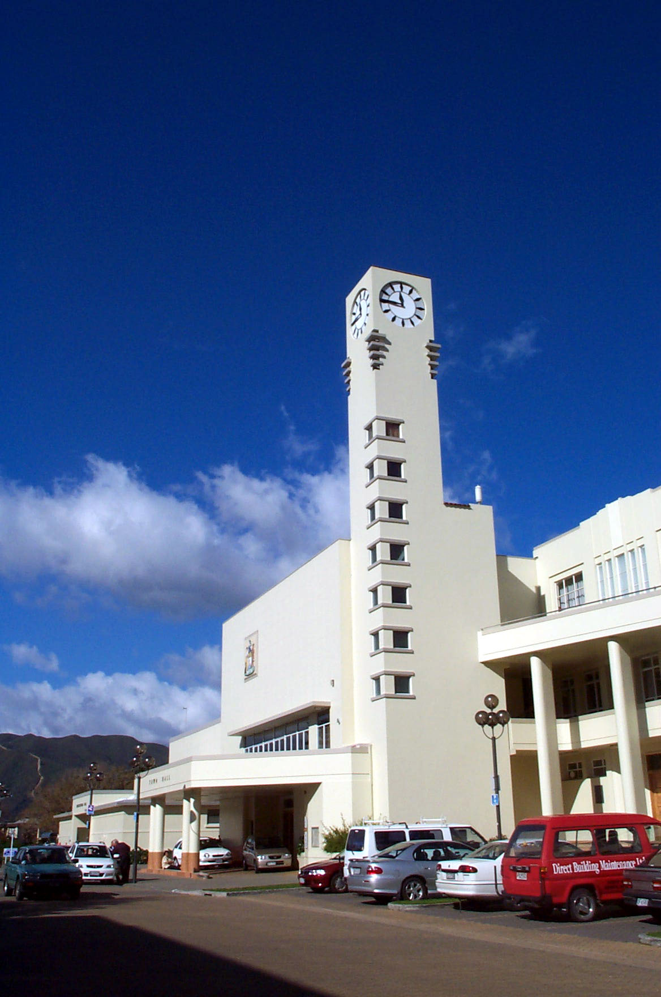
Lower Hutt’s Significant Post-War
Modern Movement Buildings


INDEX

- Introduction 2

- Hutt Civic centre precinct 4

- Naenae, Epuni, Taita precincts 6

- Dudley Street precinct 7

- Commercial buildings 9

- Industrial Buildings 13

- Railways group 14

- Educational buildings 15

- Churches 16

- Residential buildings 18

- Structures 24

Appendix 1 Architectural styles 25

Appendix 2 Biographies of architects 28

Sources 32

1 INTRODUCTION

For the first decade after the war Lower Hutt was at the forefront of Modern Movement architecture in New Zealand. Housing and commercial developments in the Hutt Valley enabled some of New Zealand’s leading architects to fully explore town planning and functional design, key elements of the Modern Movement.

Before the war few New Zealand architects appeared interested in the new architectural theories developed in Europe in the 1920’s. Initially architects in Holland, Germany and France independently sought a new form of architecture based on functionalism and rationalism. However the housing project, Weissenhofsiedlung in Stuttgart saw architects such as Mies van der Rohe, Walter Gropius, Hans Scharoun, J J P Oud and Le Corbusier collaborate for the first time. In the 1930’s England took the lead in developing the Modern Movement with architects such as Maxwell Fry, Tecton, Mary Cowley, Sir William Owens and German Marcel Bruer practising in England

The aesthetics of the movement were based on industrial design and the use of newly available mass-produced materials such as reinforced concrete, glass and steel. Key elements of the movement included a wish to express the “machine age aesthetic”, an honest expression of the structure, use of technology, and simplicity in design.

Many of the new European buildings were multi-unit and high-density housing, industrial buildings and office towers. Theories were also emerging for large scale urban planning which involved integration of mass transportation, industry commerce and housing, reflecting Europe’s highly urbanised nature.

In contrast, by 1951 more than two thirds of the population of New Zealand lived in centres of less than 25,000. Life and the economy in New Zealand was largely rural with a tiny manufacturing sector. There was little cultural life and a small intellectual class: by 1945 there were only 5,000 university graduates with degrees. Few people travelled and those who did often didn’t return. It was a highly conformist culture where the exploration of new ideas was not encouraged. Immigrants were usually working class English who largely maintained the status quo.

The situation began to change in the late 1930’s and early 1940’s. A few artists, novelists, poets and musicians began to look at a New Zealand identity in their work published in new magazines and books such as Landfall. A number of Jewish migrants came to New Zealand to escape persecution and brought with them European ideas, one of whom was the internationally recognised architect, Ernst Plischke, a Viennese émigré.

The war itself played an important part in changing architectural attitudes. The war considerably slowed the construction industry with little work for architects beyond buildings for the war effort. Elderly architects retired and the younger architects, who joined up, were able to experience the European and, later, English vision. Many took the opportunity for further study in England and Europe through repatriation scholarships and in many post war New Zealand buildings, the influence of the English Modern Movement can be seen. Some already-qualified architects also obtained town planning degrees.

New building construction immediately after the war began to make up for the previous limited construction activity and to house the returned servicemen. By the early 1950’s New Zealand’s population had reached 2 million and housing construction in particular was a key policy of the governments of the time. Between 1940 and 1952 the population of Lower Hutt more than doubled to over 40,000. New housing was built in ever increasing numbers and large new industries were established such as the Dunlop factory.

Needing appropriate planning and servicing the newly created suburbs in the Hutt Valley, radical urban design and control solutions were implemented. New roads, subdivisions, and whole suburban centres were planned. The city centre itself was replanned with a major new road cut through Riddiford Park and an old section of the city. Lower Hutt City Council became the largest non-government developer with the Maungaraki subdivision in 1953.

The influence of the Modern Movement on development in Lower Hutt is exemplified in the new Civic Centre buildings, beginning with the first such styled church in New Zealand, St James. Andrew’s Avenue, Dudley Street and railway buildings from Petone to Taita were all built in the 1950’s with many designed by Structon Group. Houses were being designed by influential architects of the time such as Ernst Plischke, Bill Toomath and Paul Pascoe.

While some buildings have been modified considerably, such as the Structon designed Levers Brothers offices in Petone, many are largely unchanged suggesting inherent flexible design. Some houses even have the same owners, such as the Toms and Ewarts.

The initial idea behind this publication was to choose 20 representative buildings of the 1950’s. Considerably more than 20 buildings of the post-war period warranted recognition, hence a number of buildings have been grouped into precincts where their collective significance is even greater than their individual significance. Generally those most intact and examples of each building type have been chosen.

The list is not exhaustive and, as any historian will attest, is not complete. Information was gathered from contemporary publications, advice kindly given by architects practising at the time and interested individuals, the Hutt City Council archives, and the New Zealand Historic Places Trust. Unfortunately, the House and Building magazine did not usually give addresses, and sometimes even suburbs were missing from the article, making identification difficult.

All the selected buildings attest to the rapid growth of Lower Hutt from a dormitory town to a city worthy of the returning soldiers and their sacrifices made during the war.
2 HUTT CIVIC CENTRE PRECINCT

Architect: Structon, King Cook and Dawson

Dates of construction: 1956, 1957, 1959
Address: Queens Drive, Laings Road

The population of the Hutt was one of the fastest growing in New Zealand in the immediate post war era and new housing, roading, flood protection, public utilities, schools and the civic centre were planned to take account of this expansion.

It was in the time of Mayor J W Andrews who served from 1933 to 1947 that the lack of planning in the Hutt needed correcting. He appointed R D H Hill as first City Planner, “one of the first such officers in New Zealand [who] laid the groundwork for the great changes to come”. The urgent need for a civic centre was appreciated by these two men who, however, had to battle a reluctant central government for financial support. Unlike the new suburbs of Naenae, Epuni, Waiwhetu and Moera, Lower Hutt City was not planned and grew haphazardly. The location and condition of council amenities reflected this development. “Council offices were in temporary housing in the old post office, the library was rated a disgrace, there was no theatre, no central amenities, no flowers, no joy.”

The first necessary part of development of the civic centre was the reorganisation of streets in the centre of the Hutt to reduce traffic congestion and to aid easy cross and through traffic. Queens Drive on the boundary of Riddiford Park was the result, which allowed for the amenities much as were envisaged by Andrews and Hill. An added advantage of the location of the civic buildings was the pride in, and concern to maintain, the public gardens of the Hutt. It was entirely appropriate that the setting for the new centre was one of the finest public gardens in Wellington.

St James church was designed as a critical part of the Lower Hutt city centre development. It was the first of the buildings in the centre and its architect Ron Muston was asked to design the Memorial Library and Little Theatre to match the St James in style. The complex housed the library, auditorium and Plunket rooms. The Memorial Entrance Hall to the library commemorates Lower Hutt’s dead from two World Wars.

The publication observed that

“The building is set in very pleasant surroundings and with the new Free Ambulance Station and the St James Church will, when the old Vicarage and the old Library are removed, form an important group of dignified buildings worthy of the main approach into the City”.

Governor-General Sir Willoughby Norrie opened the Library buildings in 1956.

The next major addition to the civic centre was the Town Hall and administration block. These buildings were designed by King, Cook and Dawson and were opened in 1957. While essentially designed using the Modern Movement principles, Stripped Classical Art Deco influences are visible. At this time, Lower Hutt was the fifth biggest city in New Zealand and a large civic centre was seen as necessary for the size of the city. At the opening ceremony it was remarked that

“we are now in the proud position of a city with a focal centre in which a group of magnificent buildings symbolises a highly developed sense of civic pride”.

The Horticultural Hall, burnt down in 1957, was rebuilt in 1959 to the design of Keith Cook. It cost of £123,000.

By the new decade, the civic centre included the Riddiford Baths, the Library, two halls, a theatre, the administration building, Plunket rooms, and St James church and new hall. To this grouping were later added the Dowse Art Museum, courts, the civil defence headquarters, still retaining the garden setting for each.

Lower Hutt Civic centre followed the desires of a number cities in the construction of civic amenities in an identifiable central area. Unlike Wellington, the Hutt buildings have been designed according to the modern movement, however where there is a significant divergence is the garden setting and the combination of church and government. A similar, intentional plan, is that of the Government Centre in Wellington where justice, government and church all meet.
3 NAENAE, EPUNI, TAITA PRECINCTS

Architect: Ernst Plischke
Date of construction:
Addresses: Epuni, Naenae, Taita

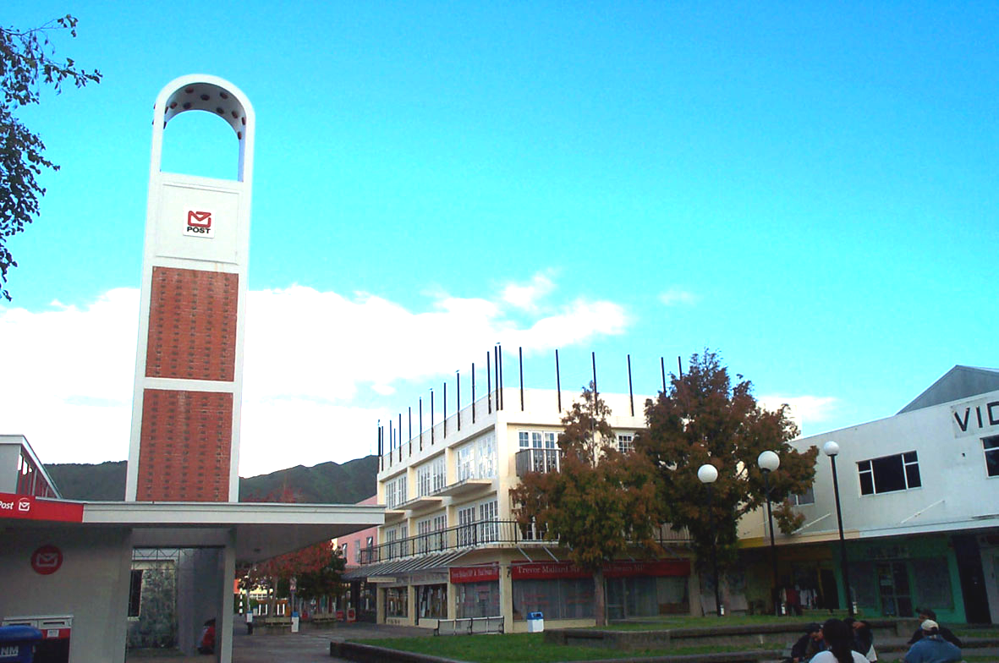

Following the end of the depression, the need for housing became urgent. The 1935 Labour government implemented a housing plan, which involved the construction of thousands of houses. Lower Hutt was a main location for building activities with design and construction carried out by the Housing Department, newly created in 1936.

The Lower Hutt City Council fully embraced the idea of town planning provided under the Town Planning Acts of 1926 and 1929. By 1935 zoning was introduced and in 1937 the allowable building envelope was regulated, following the appointment of R D H Hill as Town Planning Officer. Hill also worked with J W Mawson, the government’s chief town planner, to design a scheme for the whole of the Hutt Valley, which included all of the government’s housing schemes. Eventually over 65% of Lower Hutt housing development was carefully planned.

Between 1940 and 1952 the population of Lower Hutt more than doubled from 20,100 to 45,300. Following the war planning concentrated on housing and community development. E A Plischke, a Viennese émigré architect with the Town Planning Section of the Department of Housing Construction created designed community centres for Naenae, Epuni, Waddington (part of Naenae) and Taita.

The design for Naenae included a shopping centre with three landscaped pedestrian courts, separate car parks and consistency of building design. A theatre, gymnasium, hall, library, reading rooms, committee rooms, office buildings, swimming pool, skating rink and hotel were also planned. Some of the shopping centre planning and building design was implemented as well as the swimming pool, community centre and the Naenae hotel. The Naenae hotel was constructed in 1953.

More modest plans eventuated for Epuni and Taita, with shops, grassed area, and community halls constructed, but generally not to Plischke’s designs. The Community Hall at Epuni was designed by Structon and generally located according to Plischke’s plan.
4 DUDLEY STREET PRECINCT

Architects: F. Ost, Structon, Porter and Martin
Construction date: 1957
Address: Dudley Street

Dudley Street is the largest and most intact grouping of 1950’s buildings in the Hutt Valley. It leads into Andrew’s Avenue, which includes other 1950’s buildings, and the 1942 Post Office. The precinct includes shops, offices, warehouses and the RSA building. Most of the buildings were designed by Frederick Ost, a Viennese émigré architect, and are two storeyed, of concrete, and have large windows with simple continuous concrete frame. The RSA building, which is three stories, is more complex with chamfered south east corner and contrasting horizontal and vertical bands of glazing in the Functionalist tradition. The following are the main buildings in the street:

Valley Building (Carter Mayne)
11-13 Dudley Street
Permit issued 1953 for £25,000
Architect: F. Ost

Neilsen office building
15 – 17 Dudley Street
Permit issued September 1954, for £17,000
Architect: F. Ost

Streatham Chambers
21-17 Dudley Street
Permit issued 12/8/1958 for £12,650
Architect: F. Ost

Building
29 – 35 Dudley Street
Permit issued 18/6/1952 for £6500
Architect: F. Ost
Hutt Valley RSA
55 - 59 Dudley Street
Permit issued 25/10/1951
Architect: Structon

Government Life Insurance
15 Dudley Street
Permit issued 30/6/1958 for £25,000
Architect: Porter and Martin

Hutt Printing and Publishing
67-69 Dudley Street
Permit issued 3/5/1955 for £1,800
Architect: Structon

The Public Trust building was built in 1961.
5 COMMERCIAL BUILDINGS

NIMU

Architect: James T Craig
Date of construction: 1958
Address: 19 Laings Road

A quirky four-storey building with ceramic pipes for balustrading, the building is an early International Style building with large areas of glass curtain walling and plain, smooth concrete shear walls. The curved lift tower roof contrasts with the overall cubic forms with straight lines.

The permit for this building was issued in March with an anticipated building cost of £68,000. James Craig designed a number of other buildings in the Hutt, with the Brunette’s building another substantial addition to the streetscape.
CML BUILDING (ISP BUILDING)

Architects: Structon
Construction date: 1957
Address: 20 Laings Road

Still one of the most substantial buildings in the Hutt, the CML building permit was issued in December1957. The cost of the building was approximately £145,000 and occupies a large part of the city block bounded by Queens Drive, Laings Road and High Street.

The design of the building is clearly from the International Style. It has similarities to the Peter Jones Department Store in Sloane Square in London designed by William Crabtree between 1936 and 1939 with curved corners and repetitive shallow vertical fins. The outline of the building is defined with a simple moulded frame. In using these forms and simple decoration it maintains an early form of commercial building established by American architect Louis Sullivan in his Carson Pirie Scott store in Chicago.

The main entrance is given greater prominence than the remainder of the building with a truncated tower with a more pronounced frame. The main entrance on the Peter Jones Store, too is given prominence but by reversing solid and void.
STATE FIRE AND ACCIDENT INSURANCE OFFICE

Architect: Gummer and Ford
Construction date: 1956
Address: 15 - 21 Andrews Ave

Five stories high, the State Fire building is the tallest of the 1950’s buildings in the Hutt. The building permit was issued in April, 1956 with a projected cost of £220,240. The building is a clear Functionalist building departing from the Art Deco pleated window form of the celebrated Wellington State Insurance building, also designed by the firm.

Essentially a large rectangular form its massing is broken by projecting and receding forms, curved and flat walls, solid and void, and projecting flat cornice. The bulk is reduced further with the top floor continuous glazing. As with all Gummer and Ford buildings, it is handsome with fine detailing. The building forms an appropriate southern street boundary for the Dudley Street precinct.

NAENAE POST OFFICE

Architect: Ministry of Works and Development
Date of construction: 1959
Address: Hillary Court

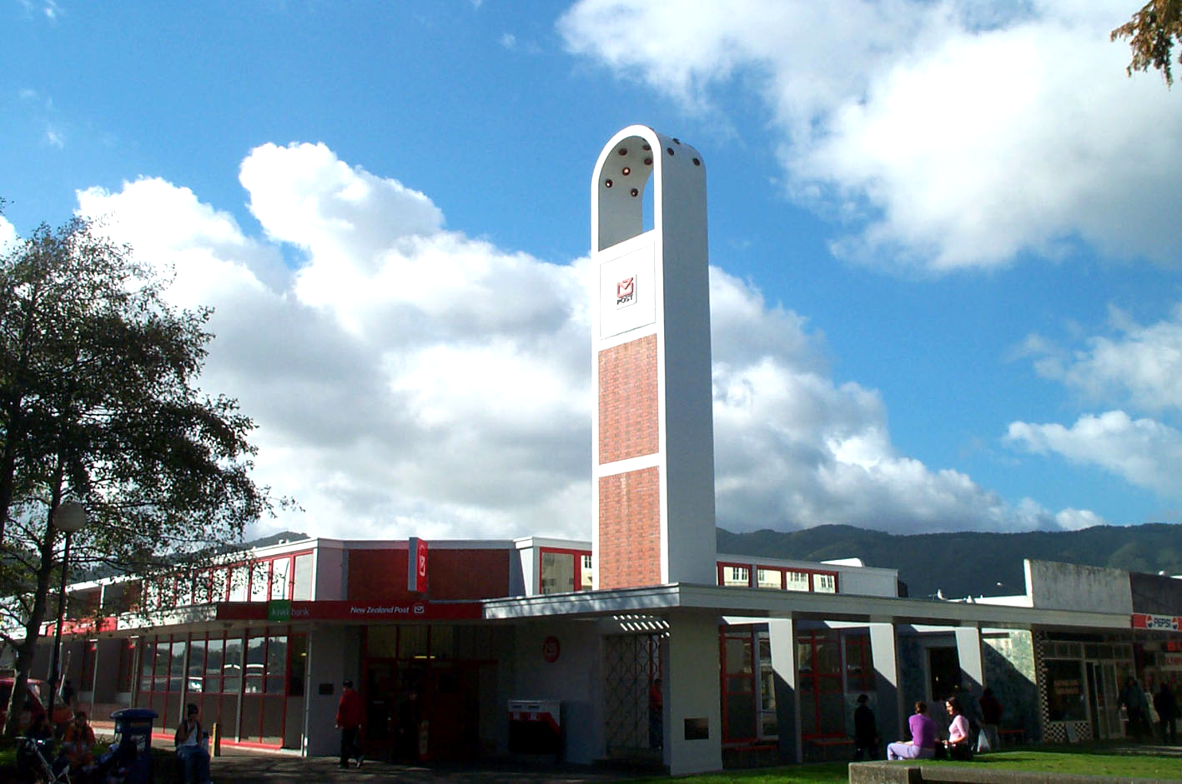

One of the central buildings in the Naenae shopping area is the Post Office. Government Architect Gordon Wilson, who was good friend of Mayor Percy Dowse, designed the building. The design of the Post Office broke current practice as it had a tower to provide a vertical accent to an otherwise flat suburban precinct.

The building was the first in New Zealand to have a mural, which was designed by artist Guy Ngan. Hon Michael Mocham, Post Master General, laid the foundation and opening plaques. The contractor was J M Construction.

The building combines brick, concrete and glass in an open and imaginative manner more reminiscent of later buildings. The tower is a possible reference to the towers of Le Corbusier, not uncommon on churches.

6 INDUSTRIAL BUILDINGS

PHILLIPS FACTORY

Architect: Gray Young, Morton and Calder
Date of construction: 1959
Address: Vogel Street, Naenae

The Phillips factory is a good example of Functionalist design, given the industrial origins of the style. Typical of the style are the long, rectangular, low scale wings, with multiple bays of glazing. Structure is expressed in the regularly spaced plain pilasters suggesting the classical origins of the most influential design of the style – German Peter Behren’s AEG factory in Berlin of 1907.

The permit was issued in 1959 and the anticipated cost was £14,550.

The factory appears to have changed little in its adaptation for Resene paints, other than the colour scheme.

7 RAILWAYS GROUP

Architect: Railways Department
Dates of construction: 1950-1954
Addresses: Petone, Epuni, Pomare, Taita, Wingate, Manor Park, Melling

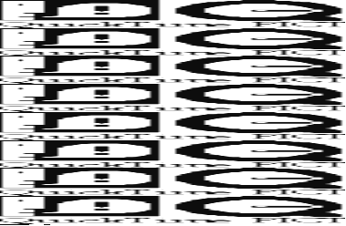

The late 1940s and early 1950s saw radical changes to the rail network in the Hutt Valley. In 1947 an extension of the railway between Waterloo and Taita was constructed to service the recent suburban development. A further extension from Taita to Silverstream was constructed in 1955. Electrification of the railway in 1953 between Wellington and Taita saw the demise of the steam trains. Two years later electrification was extended to Upper Hutt.

The new railway developments also saw construction of new stations, goods sheds, substations, and signal cabins. Within four years, twelve new buildings had been constructed. Each building is a good example of the Functionalist style, entirely appropriate to railways. The following were the new buildings of the 1950’s:
1950 Petone signal cabin
Petone substation
Taita goods shed

1951 Epuni station building
Taita station building
Pomare substation

1952 Melling station building
Naenae station building
Naenae goods shed
Wingate station building

1953 Pomare station building

1954 Manor Park station building
8 EDUCATIONAL BUILDINGS

HUTT VALLEY HIGH SCHOOL

Architect: S William Toomath
Date of construction: 1957
Address: Woburn Road

The permit for the college building was applied for in November 1956 and the design comprised two classrooms and general science library on the ground floor with five classrooms on the first floor. Toilets and cloakrooms were located in a block at the rear. The east ground floor section is open to provide a sheltered entrance and circulation to the school behind. The connection to the earlier part of the school is at first floor level via a glazed bridge stair tower.

The building is constructed of fair faced concrete and aluminium strip roofing. The structure of the interior is exposed open steel laced beams on oregon posts. The large areas of glazing and the long, sinuous form clearly stamps the design of the building in the International style.

The engineers for the building were Powell, Fenwick and Andrews.
9 CHURCHES

ST JAMES CHURCH

Architect: Ron Muston, Structon

Date of construction: 1953
Address: Queens Drive

On 6 April 1946 the previous St James church was substantially destroyed by fire. The congregation moved to the parish hall and planning began for a new church. Work was delayed while the Lower Hutt City Council formed plans to redesign the central city as the vestry decided that it wanted the church to be a component in any redevelopment. Ron Muston of the Structon Group was called in to prepare plans.

A meeting of parishioners on 13 January 1952 approved his scheme and tenders were called. W.M. Angus won the contract with a price of £54,000 and the church was dedicated on 21 December 1953.

The church design was awarded a New Zealand Institute of Architects Gold Medal in 1954. By 1955 only 17 such awards had been made and six to projects in Wellington.

In 1966 Ron Muston was asked to design an extension to the east end of the church to provide for a choir vestry. A tender of £5,220 was accepted and the addition was opened on 24 July 1967.

The design of the church is clearly of the Modern Movement in expression of forms, use of materials, colour and fenestration. This was recognised in articles published at the time.
“The design of this modern church is a break with the traditional forms, yet it retains a spiritual quality that is both inspirational and stimulating and is an expression of the age in which we live. Sir Alfred Bossom, Bt, MP, FRIBA, the eminent architect, knighted for his services to architecture in England and the United States, is publishing this year, a work entitled “Trends in Modern Church Design” in which the Church of St. James will be featured. Sir Alfred states that the church is such an important example of modern church architecture that his work would not be complete without its inclusion”

“The design now chosen - the work of Mr. R C Muston, architect - departs entirely from the Gothic. The building is dominated by the tower standing out “ stark and uncompromisingly”. Surmounting the tower is a Cross. “The bell tower is there” states Mr. Bretton [the Vicar] “to remind us, even to startle us into a realisation of what the Christian faith is. We are not dealing with any soft religion....Christ stands amidst a work-a-day world, in work-a-day clothes, to challenge it in every part to take His Way”.

This latter quotation would clearly satisfy the early proponents of the modern movement in honesty of expression, the every-day nature of modern architecture, the use of materials, and lack of ornamentation.

Of significance in the original design, and commented on the press, was the use of formica and the original porte cochere. The cork tiled flooring is also unusual, although used in F de J Clere’s St Mary of the Angels in Boulcott Street.

Other more recent churches which were clearly influenced by St James include churches at Waiwhetu and Levin.
10 RESIDENTIAL BUILDINGS

STAR FLATS

Architect: Department of Housing Construction
Date of construction: from 1958
Addresses: Moera, Petone, Naenae, Epuni, Taita

The star flats were so called because of their plan form. The architect for the Star Flats was Neville Burren of the Housing Department. The buildings contain twelve flats on three levels and was part of the then government policy of providing higher density housing. Ten of the flats have two bedrooms, while two have one double bedroom.

Part of the design of most interest to the building press at the time was the use of sliding folding French doors which opened up the external wall of the living room so that the whole room became a large sunny outdoor space. The first of the flats was constructed in Maitland Street in Auckland and those in Petone and Moera shortly after.

The architects were keen to plan the flats in a park-like setting to offset the height of the buildings and to allow for outside space for the tenants.

The design of the flats is clearly of the International style with cubic forms, expression of the structural frame and large areas of solid wall combined with large areas of curtain wall. The style, which includes shallow mono pitch roofs, wide eaves, and sun screens can be traced back to the late 1930’s and early 1940’s architecture of Le Corbusier and the English International style. A key practitioner of this latter group was Mary Crowley, whose design for a house at Tewin in Hertfordshire is reminiscent of the Star Flats.

TODD HOUSE ADDITION

Architect: Ernst Plischke
Date of construction: 1948
Addresses: 59 Wairere Road, Belmont

The original brick house was designed by William Gray Young in the neo-Georgian style. Plischke added a timber framed and clad wing onto the house in 1948 for the Todd sisters, Kathleen and Moira. The sisters found the original house cold and Plischke opened the house up to the sun with floor to ceiling glazing facing north. The addition included a new living room, bedroom, bathroom, sunroom and sundeck. The weatherboard size matches the brick courses and the whole house is painted the same colours. The cubic forms and large areas of glazing, however, contrast starkly with the prim and contained Georgian style. The addition is very successful, though radical, which enhances the original house.

Exterior stone courtyards, steps and retaining walls were designed while Anna Plischke designed the gardens, which have been retained intact.

HARDWICK-SMITH HOUSE

Architect: Ernst Plischke
Date of construction: 1948
Addresses: 124 Park Road, Belmont

This house is an ‘L’ shaped two-bedroom home designed around a central courtyard. The ends of the walls are softened with vertical timber slats. As with other Plischke houses, the interior flows into the exterior by floor to ceiling sliding doors and windows. Although very shallow, the roof is hipped.

The commission from Dr Hardwick-Smith was written on the back of his visiting card which said ”Dear Mr. Plischke, it would be very nice if you could build a house for me. Yours Dr. Hardwick-Smith”. Hardwick-Smith had seen some of Plischke’s work in Europe and was impressed by it.

TOM HOUSE

Architect: Charles Fearnley
Date of construction: 1948
Address: Corner of High Street and Military Road

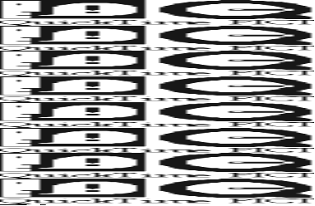

The Tom house is on the corner of High Street and Military Road. It was designed in 1948 by Charles Fearnley and is the first of the Modern Movement ‘Bay Area style’ houses in Wellington, a significant influence on domestic architecture in the 1950’s.

The house has two bedrooms and is designed to make maximum use of the sun. The public spaces occupy a larger taller volume, than the intersecting lower bedroom and ablution area. The living room west wall is largely glass while the hall is lit by a clerestory window above the lower block. The forms, contrasting solid and void, eaves, and colours all followed the contemporary Bay Area style.

EWART HOUSE

Architect: Charles Fearnley
Date of construction: 1948
Address: 4 Kaitawa Road, York Bay

This two bedroom house maintains the Bay Area style popular with Charles Fearnley in his smaller houses. The sun room entrance was typical of the Bay Area style houses designed by William Wurster who Fearnley appears to have admired. Also consistent with Wurster’s houses, are the floor to ceiling multiple square proportioned windows of the entrance, the stained weatherboards and white trim. The shallow pitched skillion roof was originally covered with fabric roofing.

The interior of the entrance has exposed rafters, originally painted yellow, while the remainder of the house had painted fibrous plaster linings. The fire surround and hearth were lined with quarry tiles.

The building cost noted on the permit drawings was £2,100.

HOUSE

Architect: Bill Toomath
Date of construction: 1957
Address: Corner Burnton St/Oxford Street

At the same time as designing the Hutt Valley High School classroom block, Bill Toomath designed this house, also in the International style. The house comprises two and single storeyed rectangular forms with extensive glazing to the north and walls with few openings in the south. Having trained at Harvard, Bill Toomath was aware of the architecture of Richard Neutra and Mies van der Rohe. He was also interested in creating a New Zealand style and this house appears to have both influences. Traditional New Zealand materials of timber framing, cladding and joinery have been used with Modern Movement forms and play of space, solid and void. The house is significant in the evolution of domestic design in New Zealand.

11 STRUCTURES

PIPE BRIDGE

Engineer: W G Morrison
Date of construction: 1954
Address: Hutt River

The Estuary Bridge served the industrial area of Gracefield and the Eastbourne Bays of the Hutt. The first bridge connecting the east and west banks of the Hutt River was timber and built in 1910. With expansion of the industrial area from the 1930’s, the timber bridge became inadequate structurally and functionally. It was replaced with the present ‘pipe’ bridge in 1954 which was the first in New Zealand of its size to be built of prestressed concrete beams. Designed by W G Morrison, the bridge was constructed by Wilkins and Davies and opened by the Minister of Public Works the Hon. W S Goodman. W G Morrison was an outstanding early engineer in private practice and a Wellington City Councillor for a period. He was a founding partner of the firm Kingston Morrison.

APPENDIX 1

STYLES

The Modern Movement
At the end of the nineteenth and the beginning of the twentieth century new architectural movements emerged which explored new materials, processes and forms. The immediate post-World War period was one of rapid change. In Holland there was de Stijl, as seen in the work of Gerrit Rietveld; in Germany, the establishment of the Bauhaus under Walter Gropius; and in France, the purist experiments of Le Corbusier. All were part of a new architectural movement.

The time was a quest to find a new form of architecture which was not a style but based on fundamental principles of functionalism and rationalism. As with many other periods of architectural history, those involved felt that the constrictions of previous styles and movements had to be removed, and a completely new, radical approach had to be evolved which owed nothing to the past. What, instead occurred, was the emergence of a number of new styles. These included Art Deco, Moderne, Bauhaus, the International Style, Expressionism, Futurism, Functionalism and other -isms besides. Russia formed its own version of Functionalism, termed ‘Constructivisim’.

The new approach to architecture has been termed “The Modern Movement” . This is a convenient, all embracing term for these new forms of architecture which generally emerged in the 1920’s, particularly in Germany, and which lasted well into the 1960’s.

The movement had many influence. Writing in the 1930’s Niklaus Pevsner considered that modern architecture should be functional, express materials and structure honestly and show a sense of social responsibility. Giedion, another writer of the time emphasised rationalism. It is also probable that there was a left wing political emphasis in the movement. Many new workers housing projects were designed by architects within the movement, and, following the Nazis disapproval of the movement, architects emigrated to Russia, Britain, the United States, Canada, Australia and New Zealand.

The movement was also a concern to embrace the newly available mass produced materials such as reinforced concrete, glass and steel as much as a desire for a new architecture that enabled the new styles to emerge. Significant elements of the movement included a wish to express the “machine age aesthetic”, an honest expression of the structure, use of technology, and simplicity in design. Client and architect welcomed cheapness of materials and construction. Gropius summed up the architectural desires of the movement as “Art and technique as a new unity”.

The principal styles in the Modern Movement were the International Style and Functionalism, although buildings were continued to be designed in other more traditional styles.

Functionalism
Functionalism was a part of the modern movement and was another philosophy which searched for an ideal architecture without reference to past styles. Its main tenet was that design should be functional above all else, and that using this as a basis for design it would be timeless and universal. Spatial organisation was the principle concern of architects, with aesthetics less important. The expression of function became an aesthetic in itself. This style became popular in Europe and Germany from the 1920’s and was characterised by smooth surfaces, large areas of glass, steel framing, cubic forms and no mouldings.

Frenchmen Tony Garnier and Auguste Perret were key early exponents of functionalism. They explored the possibilities of reinforced concrete in both domestic and public buildings, while German architects expressed the new aesthetic mainly through industrial architecture.

Gropius and Meyer’s Fagus Works of 1911 used a simple structural rhythm, flat roofs, extensive glazing, and there was an absence of cornice and horizontal banding. Temporarily delayed by the war until 1925, this new Functionalist style of architecture reestablished itself in the period from 1925 to the beginning of the second world war .

While many architectural practitioners were sympathetic to the emerging architectural aesthetic, there was a geographical divergence in approach and interpretation. The uncompromising Functionalist style was generally initially adopted by Germany, Austria, Holland, and Switzerland, and other followed later in the decade.
“we know no problems of form, only problems of building”

The newer building types such as flats, factories, hospitals and offices were often designed using the Functionalist style, while Banks, Government buildings and offices, town halls and other large institutional buildings commonly were designed in the Stripped Classical style.

The International Style
The International style was pioneered in the early 20th century by Adolf Loos, Perret, Behrens and Walter Gropius and was expanded by architects such as Le Corbusier, Mies van der Rohe, J.J.P. Oud, and Rietveld. The term “International Style” was coined by Henry-Russell Hitchcock and Philip Johnson in their The International Style: Architecture since 1922, published for their exhibition of “ Modern Architecture” in 1932. Their thesis was that a new style had emerged from the works of Frank Lloyd Wright, H P Berlage and Otto Wagner which was being adopted throughout the world and was rightly termed an International Style.

Henry-Russell Hitchcock and Philip Johnson considered that there were three basic principles of the International Style: spatial freedom through the use of skeletal frames with light external skin, that the exterior should express the structural framework and that there should be no applied decoration.

While mostly a German, French and Dutch movement in the 1920’s immediately after the second world war it was almost universally accepted outside the communist world. The use of the style continued into the 1960’s, especially in America where it became the norm for corporate architecture.

The Chapel of Notre Dame du Haut at Ronchamp designed by Le Corbusier was a seminal building in one path of the modern movement. It offered another approach to modernism from the functionalism Le Corbusier, himself, assisted in creating. Ronchamp
“is the fundamental turning point of the modern movement; the point at which a kind of expresionism, a sculptural approach to architecture found its way back into the fold, and, like the prodigal some, was greeted with mistrust and much rejoicing.”

The Bay Area style
The Bay Area style arose from a tradition of adaptation of the traditional English timber villas and bungalows in the Bay Area of San Fransisco. The main architects of the style between the 1920’s and 1940s included William W Wurster, Dinwiddie, Funk, and Born who in turn followed Arts and Crafts exponents Bernard Maybeck and Ernest Coxhead. Typically the houses were suburban, small-scale, clad with stained timber weatherboards, used natural materials especially timber interior finishes while using contemporary styles of the day. The 1930’s and 1940’s versions, most influential on New Zealand architects, merged the traditional materials with Modern Movement forms. Wurster in particular, used flat roofed cubic forms, wide overhanging eaves, contrasting areas of solid and glass walls with open planning. Even in the smallest houses, he designed large glazed entrance lobbies doubling as ‘living porches’.

Key New Zealand practitioners included the Group, Vernon Brown and Paul Pascoe,
APPENDIX 2
ARCHITECTS

Charles Fearnley
Charles Fearnley began studying architecture in 1935 and worked for a number of practices in Wellington before forming his own practice including being an articled pupil of Stanley Fearn. He was elected an associate of the Institute of Architects in 1944 and a Fellow in 1971. He became known for his low cost housing and later for his photography and publications on old buildings.

Bill Toomath
Bill Toomath was born in the Hutt Road, Petone in 1925, when his father was a chemist. He was educated at Hutt Valley High School where he became dux. His architectural career began when he worked for Crichton Mckay and Haughton as junior. In 1945 he began studying architecture at Auckland University, qualifying in 1949. At this time he designed the house in Burnton Avenue for his parents and other houses in Belmont. He was awarded a Travelling Scholarship, which allowed two years spent in Europe. In 1953, with a Fulbright Scholarship he was admitted to the Harvard University Master Course, which had been directed by Walter Gropius. IM Pei was a visiting professor who, following a successful design for a shopping centre offered Bill a job with his firm in New York for 18 months. Returning to New Zealand in 1954, he initially worked with Bernard Johns, and while in the practice designed Wool House. He established his own practice in 1955 in Wellington. An early speciality was the design of gymnasiums as, with engineer Latham Andrews, he developed an economical standard gymnasium design. He designed approximately 12 in the North Island which lead to educational work, including the work at his old school, Hutt Valley High School. His design work included a number of houses in Wellington and Lower Hutt. By 1958 he joined with Derek Wilson who practised as Toomath and Wilson until 1988. For a period the firm amalgamated with Jim Beard and Al Gabites in 1970’s, and following the dissolution of this arrangement, the firm enlarged into Toomath Wilson, Irvine and Anderson, which continued until 1988. Major projects for the firm included the Wellington Teachers Training College in Karori, the present NIWA buildings and planning for Wellington Polytechnic. Between 1979 and 1989 he was the head of the School of Design at the Polytechnic after which, although retired, successfully campaigned to save the Town Hall and continues to give planning advice to the Wellington City Council.

Ron Muston
Ron Muston was in Born in England and emigrated with his family to New Zealand when a small boy. He was educated at Auckland Grammar and obtained his architectural training at Auckland Architecture school. Ron Muston became an associate of the NZIA in 1936 and became a partner in Walker and Muston in Auckland but came to work in Wellington on his own about 1939-40. A major project with Walker and Muston was the Whakatane Paper Mills factory in Whakatane. He worked with Edmund Anscombe and Associates on the designs of the NZ Centennial Exhibition in Wellington in 1940. During WW2 he served in the Army and rose to the rank of Captain. Ron Muston was awarded an OBE and Honorary Fellowship of the American Institute of Architects. Ron stated was interested in church architecture and he designed extensions to the Nelson Cathedral, the new St James Church and the Upper Hutt St Joseph’s Orphanage and Chapel. Among other activities, Ron Muston was chairman of the Mary and Percy Dowse Foundation Board, was a member of the Board of Management of the Dowse Art Gallery and Chairman of the Board of Trustees for the National Art Gallery War Memorial and Museum.

King Cook and Dawson
The firm began with J M Dawson who established his own practice in 1906. His buildings include the T.G. McCarthy Building, Willis Street (1913), Hatricks Motor Garage (now Manthel Motors), corner Taranaki and Wakefield Streets (1913), and the Hope Gibbons Building, Dixon Street (1925).

His son, Jim Dawson, took over the firm and joined with J I King, an architect and engineer. Keith Cook, an architect joined the firm which then became King, Cook and Dawson. (Keith Cook was born in the same house in Petone as Bill Toomath). The firm designed many commercial, civic and residential buildings, especially in Lower Hutt, where the firm was based. Keith Cook’s own house in Belvue street is a good example of his houses designed in the 1930’s which had a modern Dutch influence, These included houses in Lowry bay and the Marina Grove block of flats. Keith Cook withdrew from the firm in the 1970’s from ill health and Jim Dawson died in 1999. The name of the firm has reverted to King and Dawson.

James T Craig
James T Craig, AIAA, ANZIA, was born in Balclutha in 1908 and began working with Alan Ford Architect in Invercargill. He worked in Edmund Anscombe’s office with Bill Chick and Sydney Drake on Wellington Exhibition and Herd Street Post Office. Following the war, Craig worked for Williamson Construction involved mainly with freezing works in Pareora, Palmerston South and Canterbury. During this period he was involved in domestic architecture, additions to the Fox Glacier Hotel and light commercial work.

In 1951 he set up in practice in Nathans Building in Grey Street. His projects consisted of a wide variety including: cinemas for Kerridge Odean, the Church of Christ in Lower Hutt, Catholic churches in Newtown, Opunake, Levin, Church of England in Stokes valley and presbyteries, new hotels in Naenae, Levin, Waikanae, Taita, the Caledonian at the Basin Reserve and refurbishment of the Thistle and Regent in Wellington. Two projects of note were the competition winning Oamaru Memorial Gardens and the Palmerston North Clock Tower done in conjunction with Ron McMillan. A significant client was Wakefield Hospital, then operated by the Little Company of Mary, which continued for many years. In the 1960’s he developed an affordable and simple design for primary school halls which are universal to many schools in the greater Wellington area.

Commercial work in the Hutt Valley includes the Upper Hutt City Council building, Brunettes Building, Sharpes Grains and Seeds and the SIMU building on the corner of Queens Drive and Laings Road. The mainstay of the practice however was the domestic work which was expanded when Gordon Moller and Jon Craig were invited to join in forming Craig Craig Moller Limited in 1969.

Ernst Anton Plischke (1903-1992)
E A Plischke emigrated to New Zealand in 1938 when he joined the Department of Housing Construction and was appointed Community Planner. Prior to his emigration he practised architecture in his native Vienna and in 1935 he was awarded the Great Austrian State Prize for Architecture. He studied with Peter Behrens and worked with Joseph Frank in the Werkbundseidlung. In J M Richards Introduction to Modern Architecture, a seminal publication in the promotion of Modern Movement architecture, he is mentioned as one of a number of architects who had contributed to the development of modern architecture in the 1920’s and 1930’s. In the Department of Housing he was responsible for the design of a number of flats, urban designs of Tamaki, Mangakino, Epuni, Naenae, Taita, and Trentham, In 1941 he commenced practice on his own and designed many houses, churches, community centres, several industrial buildings, the Abel Tasman Memorial, a desk for the wedding of Princess Elizabeth, and, with Cedric Firth, he designed Massey House.

Frederick W Ost
Freddy Ost was Austrian and emigrated after Plischke, just before the war. He had is own practice in Wellington and also worked for the WCC in 1960’s and 1970’s. Apart from the many commercial buildings in Dudley Street, he also designed many of the UEB factory buildings in Moera on Randwick Road. He also designed flats in Brooklyn Road. He moved to Paraparaumu.

William Gray Young (1885–1962)
Gray Young was born in Oamaru. When he was a child his family moved to Wellington where he was educated. After leaving school he was articled to the Wellington architectural firm of Crichton and McKay. In 1906 he won a competition for the design of Knox College, Dunedin, and shortly after this he commenced practice on his own account.

He became a prominent New Zealand architect and during his career of 60 years he designed over 500 buildings. His major buildings include the Wellington and Christchurch railway stations (1936 and 1954 respectively), Scot's College (1919), Phoenix Assurance Building (1930), and the Australian Mutual Provident Society (AMP) Chambers (1950). At Victoria University he was responsible for the Stout (1930), Kirk (1938), and Easterfield (1957) Buildings, and Weir House (1930). Gray Young also achieved recognition for his domestic work such as the Elliott House, Wellington (1913).

His design for the Wellesley Club (1925) earned him the Gold Medal of the New Zealand Institute of Architects in 1932. He was elected a Fellow of the Institute in 1913, serving on the executive committee from 1914–1935 and was president from 1935–36. He was also elected a Fellow of the Royal Institute of British Architects, and achieved prominence in public affairs.

Gummer and Ford
William Henry Gummer was born in 1885 and died in 1966. In the period 1908–1913 he travelled in the United Kingdom, Europe and the United States. During this time he worked for Sir Edwin Lutyens, leading English architect of the time, and for Daniel Burnham in Chicago. Burnham was a major American architect and one of the founders of the influential Chicago School of Architecture. On returning to New Zealand in 1913, he joined the firm of Hoggard and Prouse of Auckland and Wellington until 1923 when he formed the partnership with Charles Reginald Ford. Buildings Gummer designed while in the partnership with Hoggard and Prouse include the John State Fire Insurance Building (1919), Chambers building (1917) and the Maritime Building (1919).

Gummer was an important figure in the New Zealand Institute of Architects. He was elected a Fellow in 1914, four years after having been elected an Associate, was President between 1933 and 1934, and was later elected a life member. With his association with the National Museum and Art Gallery, he was on the National Art Gallery Management Committee until 1940.4

Gummer was one of the most outstanding domestic architects working in New Zealand in the first half of this century and was responsible for the stylistically and structurally advanced Tauroa (1916), Craggy Range (1919), Arden (1926), and Te Mata (1935) homesteads at Havelock North.

Gummer also made a significant contribution to the architectural heritage in his war memorials, including that in Dunedin, the Massey Memorial in Wellington, the Bridge of Remembrance in Christchurch, and the National War memorial in Wellington.

Charles Reginald Ford was born in England in 1880 and first served with the Royal Navy before joining Scott's 1901 - 1904 Antarctic expedition. By 1909 he had emigrated from England to Christchurch, and by 1919 was working as a partner in the Wanganui architectural firm of Ford and Talboys. He also gained an expertise in engineering, writing a treatise on earthquake resistant building design. He was elected President of the New Zealand Institute of Architects between 1921 and 1922 and is recognised for his contribution into research on earthquake engineering.

The firm was responsible for many public buildings throughout New Zealand including the State Insurance Building (1940), Agricultural House (1937), Wellington City Gallery (1939), in Wellington, the Dilworth Building (1926), the Guardian trust Building (1921), the Domain Winter gardens ( 1928), in Auckland, and the Dominion Museum War Memorial and Carillon (1936) in Wellington. Gummer and Ford were awarded Gold Medals from the New Zealand Institute of Architects for the design of the Auckland Railway Station and Remuera Library.
SOURCES

Personal discussions
Alex Bowman Geoffrey Thornton
Bill Sheet Greg Bowron
Bill Toomath John Adam, Structon
Derek Wilson Jon Craig
Dr Jock Phillips Julia Gatley
Dr Paul Walker Justine Clarke
Evzen Novak Linda Tyler
Martin Hill

Archives
Hutt City Council archives
New Zealand Railways

Periodicals
Home and Building
Building Progress
NZIA Journal

Publications
Apperly, R., Irving, P., Reynolds, P., A Pictorial Guide to Identifying Australian Architecture Styles and Terms from 1788 to the Present, Angus, 1989
Cuffley, Peter, Australian Houses of the Forties and Fifties, The Five Mile Press,
1993
Curtis , William J R, Modern Architecture Since 1900, Phaidon, 1996
Hatje, Gerd editor, Encyclopaedia of Modern Architecture, Thames and Hudson, 1971
Heathcote , Edwin and Spens , Iona, Church Builders, Academy Editions, 1997
Jencks, Charles, Modern Movements in Architecture, Pelican, 1973
McGill , David, Lower Hutt, The First Garden City, The Lower Hutt City Council, 1991
Miller , David P., Once Upon A Village. New Zealand University Press, 1972
Pevsner , Nickolaus, The Sources of Modern Architecture and Design, Thames and Hudson, 1985
Richards , J M, An Introduction to Modern Architecture, Pelican Books, 1940
Sharp , Dennis, editor, The Rationalists Theory and Design in the Modern Movement, Architectural Press, 1978
Wilson , John, editor, Zeal and Crusade, The Modern Movement in Wellington, Te Waihora Press, 1996
Woodbridge, Sally, editor, Bay Area Houses, Gibbs Smith, 1988
Woodbridge, Sally, Bernard Maybeck, Visionary Architect, Abbeville Press, 1996

Design, text and photography by Ian Bowman Architect and Conservator

© Ian Bowman and Hutt City Council

Printed by Anco Print, Petone 2002

ISBN 1-877179-03-5

